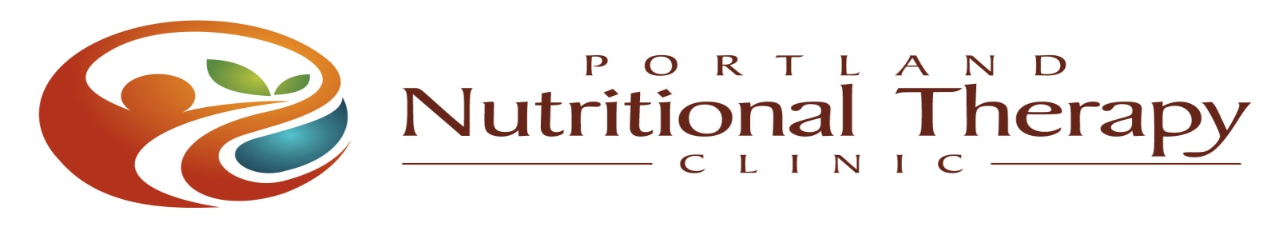

**NTP Clinical Skills Internship**

*Building Nutritional Therapy Practice Confidence, Efficiency and Successful Protocols*

**Dates: Friday-Sunday, October 5-7, 2012**

**Location: Healing Path Holistic Medicine Clinic**

**3880 SE Harrison Street, Milwaukie, OR 97222**

**(503) 513-4665 Email: pdxnutritionaltherapy@gmail.com**

**Price: $475.00 – includes internship materials, space limited to 5 Interns**

NTA Approved 18 CEUs -- Application and Registration Information available at:

<http://www.healingpathclinic.com/nutritional-therapy/for-practitioner>

**Application Deadline August 15, 2012**

**\*\*\*\*\*\*\*\*\*\*\*\*\*\*\*\*\*\*\*\*\*\*\*\*\*\*\*\*\*\*\*\*\*\*\*\*\*\*\*\*\*\*\*\*\*\*\*\*\*\*\*\*\*\*\*\*\*\*\*\*\*\*\*\*\*\***

**Are you an NTP looking for ways to streamline your client appointments, hone your clinical skills, and successfully grow your practice? Join us for this 3-day NTP Clinical Skills Internship where you’ll perfect your technique, master protocol development, and leave as a more confident practitioner!**

INTERNSHIP HIGHLIGHTS

Review/Mastery of Functional Evaluation Skills Case Study Review of Complicated Cases

Receive a Nutritional Therapy Initial Evaluation Shadow a Client Consultation to Learn Efficiency

Evaluate a New Client with Fellow Intern Present a Client Clinical Review

Evaluate a New Client One-on-One with Review of Case Studies: Tailoring the NTP

Instructor Supervision Approach with Complicated Clients

Group Discussion on Developing Nutritional Therapy Introduction of Additional Evaluative Tools

Protocols, Goals and Plans and Trainings for NTPs

*Meet Your Instructors*

**Cathy Eason**, NTP, CGP, CHFS, LMT; Lead Instructor, Nutritional Therapy Association, Inc.; Owner, Abundant Health, LLC ~ **Co-Creator and Intern Instructor, Cathy Eason**  began her pursuit for knowledge of health and the human body while in college studying Exercise Science and Physiology, and her quest for holistic truth hasn’t stopped since. She has taught the NTP training program across the country for the NTA for 6 years, and has been in private practice in nutritional therapy and bodywork since 1997.

**Anja Middelveld**, NTP, L.Ac, LMT; Owner, Healing Path Clinic, LLC ~ **Co-creator and Facilitator**, **Anja Middelveld** started her career in natural health back in 1994, and continues to educate herself with pieces of the puzzle to provide the best natural healthcare she can. In 2004 she opened up the doors to Healing Path Holistic Medicine (also home to Portland Nutritional Therapy Clinic), where she practices acupuncture and nutritional therapy.